Summary of issues to be considered by SPS Measurement Team

Basics:
The SPS PIVIE (Peripheral IV Infiltrate – Extravasation ) HAC has made rapid and very good progress since the initiation of this HAC.
The two major mechanisms of PIV associated harm are:
- Fluid Volume harm
- PIV medication local pharmacological /chemical / physical toxicity
Detailed discussion of these mechanisms and other Cincinnati system material is available online at: http://stopivharm.org/
A verbal presentation is available at: http://cchmcstream.cchmc.org/MediasiteEX/Play/245d5d325a5d487793d1446b9d7b8f3a1d
Dallas Children’s and Cincinnati Children’s Vascular Access Teams have worked extensively on PIV harm prevention initiatives for many years. The Vascular Access leaders at both institutions have had numerous discussions and co-operated in this work.
NOTE: the terms “extravasation” and “infiltration” are used variable in the literature. For this document, the term “extravasation” will be used to mean both “extravasation” and ”infiltration”

Medication Toxicity Component
Based on work at both of these institutions, it has become very clear that the highest risk and the major cause of PIV harm is the administration of tissue toxic medications via a PIV. These medications are called “Vesicants” in the Dallas terminology and “Red Drugs” in the Cincinnati terminology. Dallas and Cincinnati substantially agree on this issue and on the specific drugs which are highest risk. In our view, strategies aimed at the minimization of PIV administration of these tissue toxic drugs will result in the greatest reduction of harm across the SPS network and should be the major focus of our initial SPS work

Fluid Volume Extravasation / Infiltration Component
Undetected gross extravasation of even simple I/V fluids can rarely result in compartment syndrome with serious harm.
In our opinion, late detection of major PIV tissue fluid extravasations is also an indicator of imperfect bedside nursing care and imperfect clinical leadership.
At both Dallas and Cincinnati, improvement / safety initiatives have been undertaken. In order to obtain appropriate data, both institutions independently came to the conclusion that the existing Infusion Nursing Society (INS) grading system was unsatisfactory for obtaining actionable improvement data because the INS system combined both medication toxicity and fluid volume into a single, complex, mostly descriptive grading system.
Dallas and Cincinnati therefore created pediatric specific PIV harm assessment and document systems, which separated the fluid volume and medication toxicity components.
Both institutions shared their approaches during that time.
Dallas chose to modify the INS system and introduced the concept of a percentage of swelling calculated by measuring the limb length (upper or lower limb, depending on the site of extravasation) as the denominator and the length of the swelling as the numerator.
Cincinnati chose to do a “clean sheet redesign” but adopted the Dallas percentage concept. Cincinnati developed the concept of using a single, simple body size surrogate as the denominator for all extravasations, regardless of site. The length of the upper limb was chosen as that body size surrogate for several reasons:
- Upper limb anatomic landmarks are easier to define and teach than the lower limb
- Upper limb measurement avoids palpating the diaper area
- A single denominator measurement is simpler to teach than the two denominator method
- Our guess was that there was only a small difference between upper limb and lower limb measurements, especially in children under 2 years.
The Cincinnati system is designed to be very simple because our approach is to train all bedside nurses throughout the hospital in extravasation assessment and documentation. This hospital wide education brings the PIV extravasation issue to the forefront for all bedside nurses and we believe, contributes significantly to our prevention efforts.
The Dallas system involves measuring the lower limb length as the denominator for a lower limb extravasation and the upper limb length as the denominator for an upper limb extravasation. Dallas does not train every bedside nurse in extravasation measurement. Instead, a Vascular Access nurse is called to the bedside and he or she does the estimation, so that the slightly more complex assessment system does not matter since only a few specialist vascular access nurses need to be trained.
Aaron Dawson recently found published data on limb lengths in children, and although the methodology is slightly different than either the Dallas or Cincinnati systems, it appears that the leg is about 10% longer than the arm in children under 2 years, rising to about 15% over the age of 2 years.
Rough calculations for a 10, 20 and 30cm swelling show that the Dallas system results in an approximately 5% underestimate for a leg extravasation / infiltrate of 10 cm, an 11% underestimate for a 20 cm extravasation and a 15% underestimate for a 30 cm extravasation.

In both Dallas and Cincinnati systems, the most inaccurate measurement is the length of the swelling because this is determined by simple palpation and is subject to opinion and experience.
Therefore, in our view, the 10-15% difference between using a leg denominator for a leg extravasation is almost trivial when we account for the bigger source of variability which is estimating the length of the extravasation, and the observation that even large simple fluid extravasations rarely result in serious permanent harm, unless the extravasation is extreme.

SUMMARY:
Simple fluid extravasation is the less important class of potential PIV harm compared with tissue toxic drugs.
The minor technical differences between the Dallas and Cincinnati assessment systems is likely to not significantly affect the overall SPS improvement efforts.
If either the Cincinnati or the Dallas system is chosen as the only system allowed for the SPS PIVIE HAC initiative, changing any institution currently on the other “non-approved” system will be very difficult and just cannot be achieved in a practical time frame.
Therefore we recommend SPS approve use of either the Cincinnati or Dallas system. Hospitals which still use the old INS single grading system will not be able to participate in data gathering unless they somehow separate out the medication toxicity from the volume data.
If necessary, for comparison between hospitals in the future, a correction/ conversion factor could be retrospectively applied to data derived from either system, provided individual hospitals record which limb is involved and record the actual arm and leg measurements. SPS cannot receive patient identifiable data.
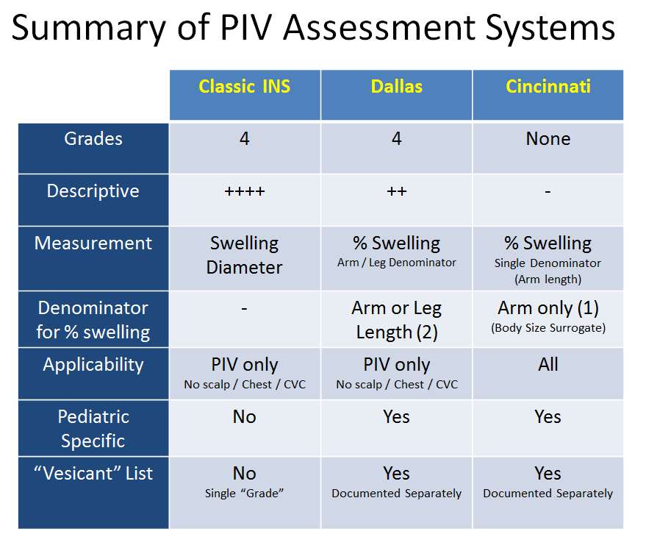

References:
- http://stopivharm.org (Cincinnati system documents)
- A Pediatric Peripheral Intravenous Infiltration Assessment Tool
Simona, Rodica Pop, PhD, RN
Journal of Infusion Nursing: July/August 2012 - Volume 35 - Issue 4 - p 243–248

- Handbook of Physical Measurements
Hall, J et al Oxford University Press 2007

- Reducing Risk of Harm From Extravasation – A three tiered evidence based list of pediatric peripheral intravenous infusates. Clark, Eloise et al
Journal of Infusion Nursing: Volume 36 Number 1 Jan / Feb 2013

