Commentary on the Cincinnati Pediatric Intravenous Extravasation Assessment and Documentation System in Relation to INS and other Grading Systems
December 2, 2014
Definitions:
“Extravasation” is used to describe any inadvertent deposition of intended intravenous fluids, infusates (such as Total Parenteral Nutrition) or medications into local tissues. We do not use the term “infiltrate” in relation to IV extravasation injuries
“Vesicant” This term is derived from chemical warfare agents and literally means “blistering agent” Since many serious Intravenous Extravasation Injuries do not involve skin blistering, we do not use the term.
“Harm” is unintended physical injury resulting from … medical care. (Institute for Healthcare Improvement – IHI) We define three levels of intravenous extravasation harm (see below)

Background:
The “Cincinnati Intravenous Extravasation Assessment System” was originally developed to support the overall Peripheral IntraVenous (PIV) extravasation harm prevention work at Cincinnati Children’s Hospital Medical Center (CCHMC) from 2007-2014. This Assessment System was subsequently modified to accommodate all intravenous extravasation occurrences, including extravasation complications related to PIV at any anatomic location, tunneled and non-tunneled central lines, PICC lines and subcutaneous ports. We have made it clear during presentations about this system that the Assessment System itself will not cause significant reduction in extravasation harm unless supported by a comprehensive improvement effort led and sustained at the general institutional level.
Our early work attempted to use a locally modified version of the Infusion Nurses Society (INS) Grading System which was the de facto national standard for PIV extravasations at the time. This system was unworkable for supporting our institutional data driven quality improvement approach for the following reasons:
- The INS system used a four level arbitrary grading system which has never been shown to accurately track severity of harm or predict outcome in pediatric patients. (The INS grading system is no longer recommended by the INS).
- The grading system combined the two main mechanisms of PIV injury, namely Volume and Local tissue drug / medication toxicity, into a single combined “grade”
- Much of the grading criteria were subjective descriptions, sometimes repeated in the definition of multiple grades.
- Definition of the worst grade (Grade 4) included any amount of subcutaneous tissue extravasation of a “vesicant medication or blood” such that 1ml or 100 ml of a so called “vesicant” medication resulted in the same assignment of a Grade 4. There was no INS standard list of “vesicant medications” and each institution was expected to develop its own.
- The INS grading scale was very sensitive (all historic CCHMC serious PIV harm had originally been assigned a grade 4) but not specific (very few Grade 4 episodes led to serious adverse outcomes). Thus, despite significant improvement efforts by test units at CCHMC, the number and proportion of PIV extravasations documented as Grade 4 did not change significantly.
For these reasons, we explored alternate PIV extravasation assessment and document systems.
We had a number of teleconferences with leading institutions, especially the Children’s Health Dallas vascular group and we acquired the idea of measuring the PIV extravasation size as a ratio of the swelling length / limb length from the Dallas group.
The Dallas group has published an important pediatric modification of the INS grading scale which introduced the concept of a ratio for estimating swelling, but retained the basic four INS grades with modified descriptors, and this Dallas pediatric modification of the INS scale has been adopted widely.
The denominator for the swelling (volume) ratio in the Dallas system is the arm length for an upper limb extravasation, and the leg length for a lower limb extravasation. Even though the measurement tool was developed and used for this study by their vascular access team, the published description does not define the exact anatomic landmarks for measurement of the relevant limb length, and provides no guidance for which denominator should be used for extravasations into chest, scalp or neck sites.
[Pop, RS. A Pediatric Peripheral Intravenous Infiltration Assessment Tool. Journal of Infusion Nursing. Volume 35, Number 4 July / August 2012 pp 243 – 248 ].

Development of the Cincinnati PIV Extravasation Assessment and Documentation Tool:
We decided to take a “clean slate” approach and design an extravasation assessment and documentation system that would provide accurate numerical IV extravasation data in order to support our institutional data centric improvement methodology, without presuming or pre-selecting any data segmentation (grading)
Important components of this CCHMC clean slate design include:
- Separation and therefore separate documentation of the two basic components of IV Extravasation harm: – Extravasated Fluid Volume and Local tissue drug / medication toxicity potential
- A continuous, numeric scale for PIV extravasation volume estimation using a ratio of extravasation site local tissue swelling divided by a convenient and easily measured body size surrogate expressed as a percentage
- No subjective descriptive criteria
- Development and incorporation of an interdisciplinary, evidence based, three tier (Red – Yellow – Green) ranking of extravasated medication tissue toxicity potential (“vesicants”)
The resulting Cincinnati PIV Tool and more importantly, the associated harm reduction strategies and processes have been successfully implemented at the following US hospitals:
- Cincinnati Children’s
- Cook Children’s (Forth Worth)
- Lurie Children’s (Chicago)
- Colorado Children’s Hospital
- Children’s Healthcare of Atlanta

The development of the Cincinnati three tier medication toxicity listing has been published [Clark, E. et al. Reducing Risk of Harm From Extravasation – A Three Tiered Evidence Based List of Peripheral Intravenous Infusates. Journal of Infusion Nursing Volume 36, Number 1. Jan / Feb 2013]

The Cincinnati extravasation assessment tool is shown below:

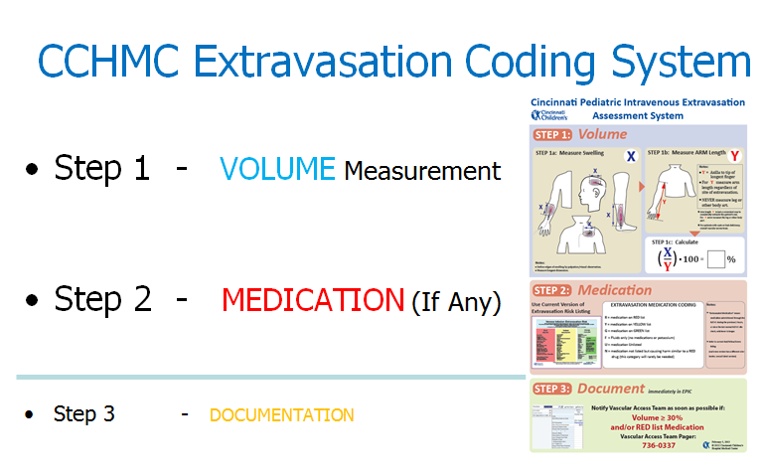
The main documentation of our extravasation assessment system, including the RYG toxicity listing and a recorded oral presentation with associated downloadable power point is available at:
http://stopivharm.org

The Original pdf document of the Cincinnati IV extravasation tool is available at:
http://stopivharm.org/images/Cincinnati_PIV_Extravasation_and_Documentation_Assessment_System.pdf

Important Features of the Cincinnati Tool are:

- The tool is used for all intravenous extravasations, not just PIV extravasation.
- The tool allows convenient and simple assessment and documentation of any extravasation at any anatomical site, including the chest, neck and scalp
- We use a single, convenient, carefully defined body size surrogate measurement (arm length) for the denominator of the extravasation volume ratio calculation. We considered other body size surrogate measurements such as Weight, Body Mass Index, Head Circumference, Body Surface Area etc., but we chose the arm length because of its simplicity and almost universal availability. The only equipment needed for the measurement is a tape measure. No other clinical measure of area or volume, such as burn percentage, uses a different denominator depending on the anatomic site of the lesion and we see no reason to complicate our assessment tool by using different body size denominators depending on the anatomic site of an extravasation.
- The tool clearly separates the two main components of intravenous extravasation harm allowing separate prospective documentation and tracking of the occurrence frequency and harm potential of the two components.
- The tool together with associated harm reduction initiatives has resulted in only one occurrence of non-code, serious IV extravasation harm at CCHMC in over 6 years.

Associated IV Extravasation Harm Reduction Initiatives

We have defined three CCHMC levels of Intravenous Extravasation Harm:

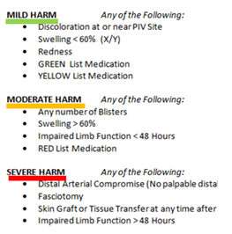

We use these harm definitions and our intravenous extravasation assessment system in official hospital policy to guide treatment decisions:

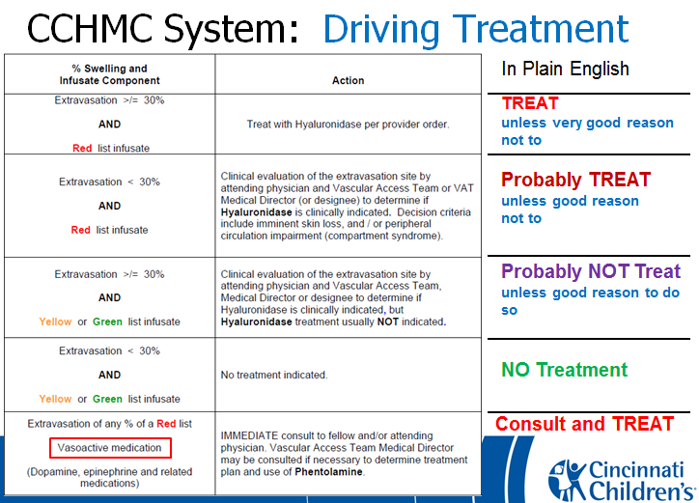

The whole CCHMC initiative is described in detail in the oral presentation and associated documentation available at:
http://stopivharm.org

Contacts:
Neil Johnson MD: neil.johnson@cchmc.org
Sylvia Rineair RN: sylvia.rineair@cchmc.org
Darcy Doellman RN: darcy.doellman@cchmc.org
Recent discussions with Children’s Health Dallas Vascular Access Leadership – Melissa Whitehead RN

I had a very helpful, informative and enlightening discussion with Melissa last week. We discussed a wide range of issues relating to PIV Extravasation harm and prevention strategies. I will use “extravasation” below to mean either extravasation or infiltration as used by other institutions and the INS.
I hope that I can summarize our discussion accurately as follows:
- Dallas has chosen to use their vascular access team nurses to do the majority of the PIV extravasation gradings and EPIC documentation and therefore avoided the need to train all general nurses at their institution.
- Most PIV’s are placed by their vascular access team and that is how they discover the majority of the PIV extravasations.
- Melissa has done a small non formal study of the difference between arm and leg length in the younger patients (< 8 months) and found the difference is around 10%. The percentage increases to 20% in older children (> 150 cm tall)
- Dallas, Cincinnati and some other US pediatric institutions have been working on this issue for a long time whereas other institutions are just beginning on the journey.
- We both suspect that there is a wide variation in hospital quality / improvement / safety culture / leadership structure /approach to PIV placement and management etc. Some institutions may not even have a formal vascular access team. Others have sophisticated, funded vascular access teams with varying degrees of physician input or leadership.
- Therefore, we strongly suggest that SPS should do a survey of the SPS pioneer PIVIE institutions so that we have an accurate idea of the PIV related organizational environment for each institution. It is important in our view that the SPS survey should be done as an early priority.
- We have both essentially concluded that the most important component of PIV harm reduction is the avoidance or risk minimization for tissue toxic PIV medications or drugs. These meds / drugs are referred to as the “Red medications” in the Cincinnati system and “High Risk Vesicants” in the Dallas system and vesicant in the INS system. Conversely, while the simple “fluid volume” component is important, especially to the patient, it is less dangerous long term than the vesicant or red drug component. Neither institution has had a case requiring fasciotomy for several years, despite some volume extravasations of > 100%
- We therefore advocate that the SPS group should prioritize the medication / red drug / vesicant issue over the volume issue
- We discussed the idea of increasing the Cincinnati moderate harm volume threshold from 60% to 70% which would allow for the estimated 10% difference in arm – leg length measurement and then institutions could choose either the Dallas or Cincinnati scale and SPS would obtain consistent data. It is important however, that the medications or drugs extravasated should be separately documented and submitted to the SPS data analysis process. Melissa and I discussed this issue again today and she suggests changing categories to “moderate = 30-60% and severe > 60%”? Considering where other organizations are in their journey.
Comment:
It became clear to me during and after the conversation with Melissa that Dallas and Cincinnati have both been successful in reducing harm from IV Extravasation / Infiltration but have taken some different approaches, but have many common approaches and experiences.
Dallas has kept the grading of extravasations within the Vascular Access Team and therefore avoided the need to train all general nurses. I will ask Melissa to add details about their other prevention processes.
Cincinnati chose to train all general nurses (about 2000 individuals) in the use of our new assessment scale, including the Red – Yellow – Green medication list. When an extravasation event occurs, the bedside general nurse must do his or her own assessment and document that assessment in our EMR (EPIC). As soon as an extravasation > 30% or a Red Drug is documented, the Vascular Access Team (VAT) is notified electronically and a VAT nurse goes to the bedside within 15 minutes, 24/7. The VAT nurse checks the assessment and supports the nurse and physicians in managing the extravasation. The VAT nurse also gains insight into the cause of the extravasation by discussion with the responsible nurse and others within minutes of the extravasation being discovered.
I had not understood this different approach before, but I wonder if our decision to push the extravasation assessment training out to all general nurses may have made our whole institution more aware of the importance of the issues and more importantly, now that I look back, I suspect that the Cincinnati nurses may have been instrumental in making the resident / fellow physician community more aware of the red drug list and influenced their decisions on placement of a PICC or other central line.
I understand that Dallas also makes their high risk vesicant listing widely available throughout the institution, so the same “bedside nurse influencing junior physician ordering” phenomenon is probably also working at Dallas. We have only had one case of serious harm – full thickness skin loss which healed with conservative care, in the last 6+ years. We have had two epinephrine related skin injuries which occurred during codes but also healed with conservative wound care. The code team has subsequently changed its approach and now obtains intra osseous venous access much earlier in the code.
This of course raises the issue that we may have created other complications and costs by inserting too many PICC lines which are known to have a complication rate of around 30%. We will have to look into that issue in the near future.
I hope this commentary will serve as a baseline for discussion later this week at the SPS leadership call.
Neil Johnson MD.
Also discussed with and details added for the Dallas approach by Melissa Whitehead RN

